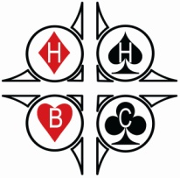

BRIDGE IS FUN

Hatfield Heath Bridge Club

Learning bridge opens up a whole new world. It keeps your brain

active and introduces you to many new friends.
Our relaxed and friendly classes are for two hours and are a mix of tutorial and play with a break for a drink, a biscuit and a chat.

“Beginners” Classes
Monday evenings starting 7.30 pm 19th September 2016

If you already play bridge but would like to
improve your game you may enjoy our

“Improvers ” Classes
Tuesday evenings starting 7.30 pm 20th September 2016

Hatfield Heath Bridge Club meets every Wednesday evening and there is now a separate section for newer players and space for Beginners to practise together

For more information contact:
Penny & Brian Hassell
Tel: 01279 721428
Email: hassells2@gmail.com

♠♥♦♣

